# **VBCS Screen - Staffing Interface**

This screen allows user to upload and update several order information before submitting and placing the order.

**1.Import Orders**

* The data will be uploaded to the staging table when user select the **Import Order.** To do this, we must fill the spreadsheet with the necessary data.
* File format of the spreadsheet should be in. Xlsx
* While uploading data the order status field must be in **Draft** Status in the excel sheet.

Excel datasheet : - [Import Data.xlsx](https://capgemini.sharepoint.com/:x:/r/sites/StaffingAdvantageProduct/Shared%20Documents/General/2%20-Staffing%20Product/VBCS-%20Import%20Staffing%20Interface%20Excel%20file/Import%20Data.xlsx?d=w6a154e0216e44ea1a515f696ea4b60f5&csf=1&web=1&e=ycphGQ)

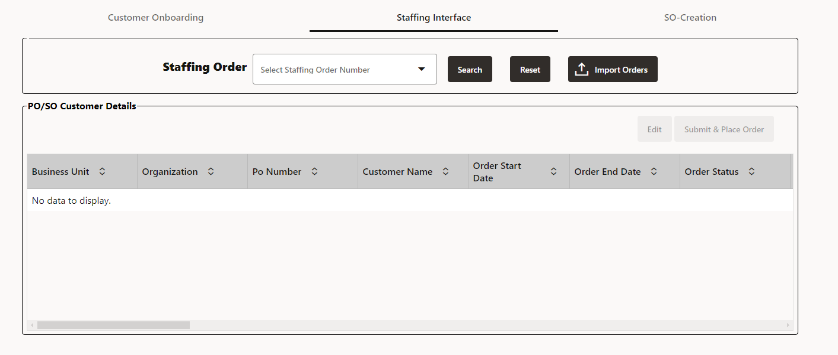

* You will receive notification that the data has been **Uploaded Successfully** once it has uploaded in staging table.

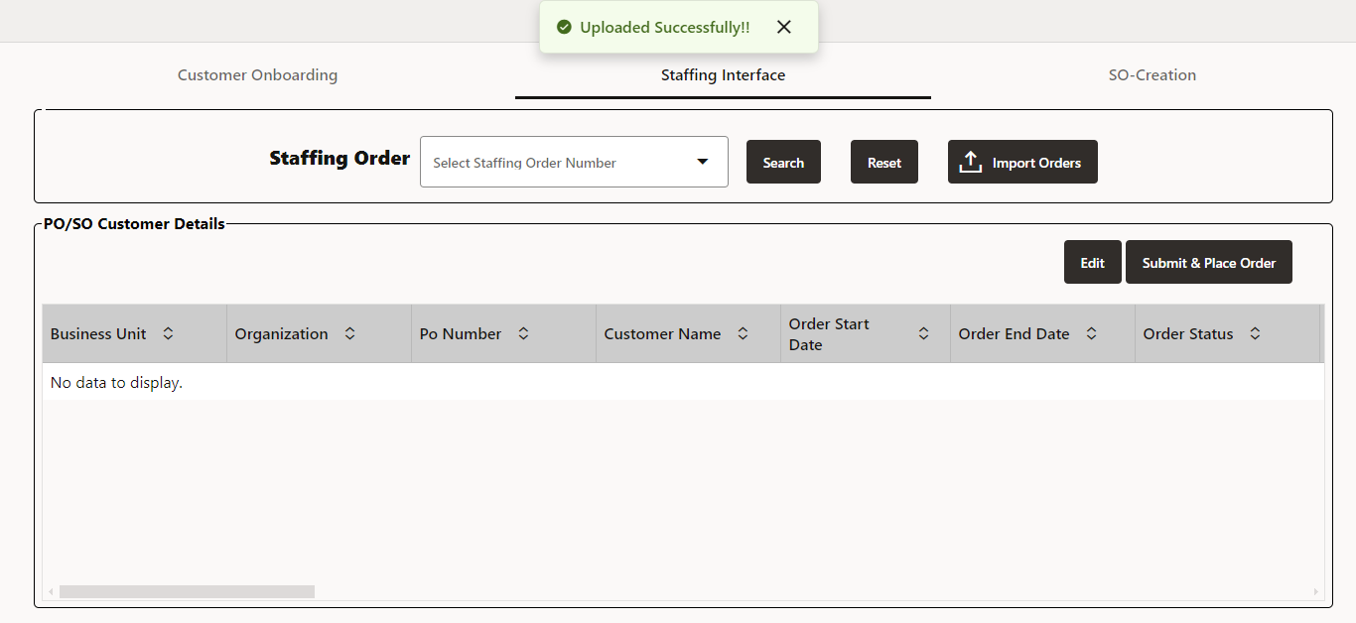

**2. Search**

User can search the specific order from LOV of the staffing order and will get the order details in the table based on it.

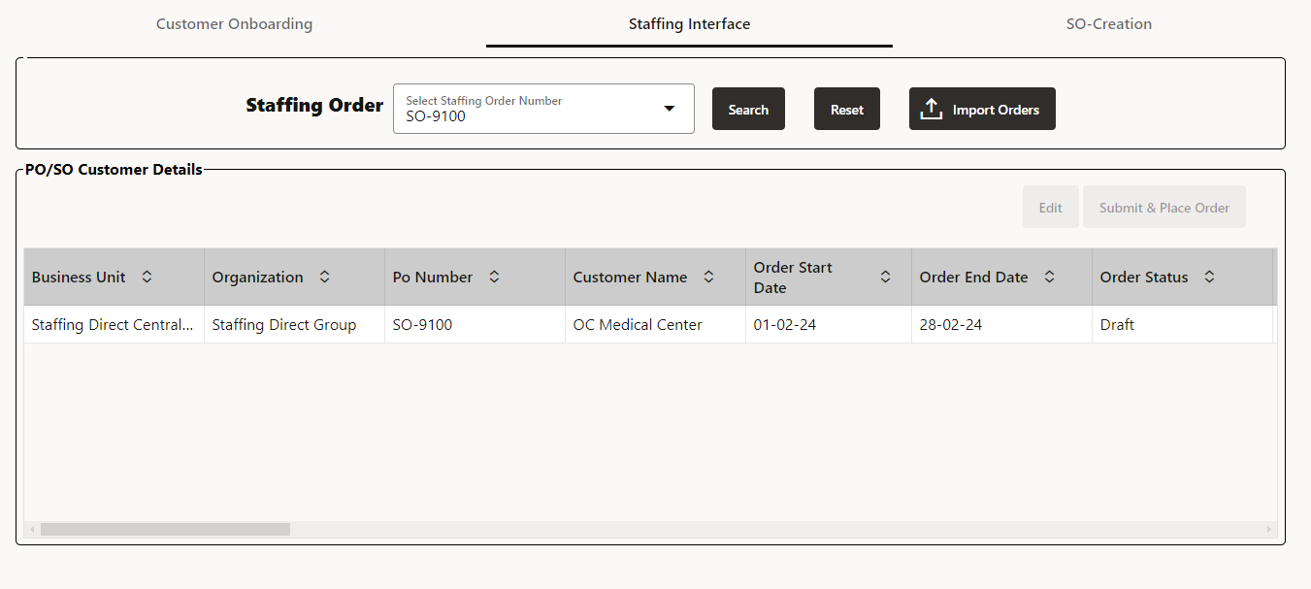

**3.Edit**

* To edit the data of order line details user can select the specific row and click on the edit button.
* The dialogue box of create line order details will display, user can edit line details from it.
* Once user can click **Ok button** all the details will save and update in the staging table.

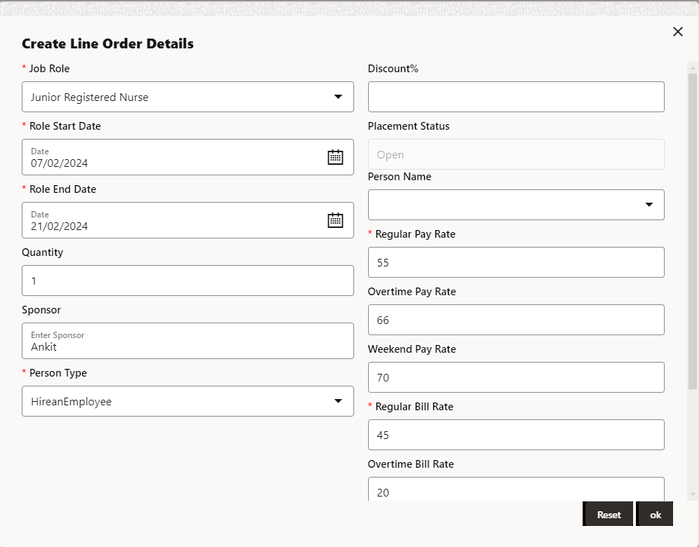

**4. Submit & Place Order**

* Users can submit and place orders by clicking the **Submit & Place Order** button. Once the order is placed and submitted, will receive notification.
* If there is no person present, then you receive the notification **Project- created successfully**and **Contract-created successfully** if person is present then you receive the notification **Project-SO- Placement successful**. (Refer the below image.)

